

EXPERIMENT 3

Execute and display the results for the following commands in Kali Linux Operating Systems: Tree Head Tail

AIM
To Execute and display the results for the following commands in Kali Linux Operating Systems: Tree Head Tail

PROCEDURE
- Open Kali Linux
- Open terminal
- tree command
  - mkdir EH -- press Enter
  - cd EH -- press Enter
  - mkdir Topic1 -- press Enter
  - cd Topic1 -- press Enter
  - touch unit1overview.txt -- press Enter
  - tree -- press Enter
- Inserting content into created Jile
  - nano unit1overview.txt
  - Type the following
Introduction to Ethical Hacking Types of Hackers and Their Roles Ethics of Ethical Hacking
Ethical Hacking and the Legal System Proper and Responsible Disclosure
  - Press Ctrl + O -- press Enter
  - Press Ctrl + X
- head command
  - head -2 unit1overview.txt -- press Enter (It lists Jirst 2 lines in the Jile)
  - head -4 unit1overview.txt -- press Enter (It lists Jirst 4 lines in the Jile)
- tail command
  - tail -2 unit1overview.txt -- press Enter (It lists last 2 lines in the Jile)
  - tail -4 unit1overview.txt -- press Enter (It lists last 4 lines in the Jile)

OUTPUT
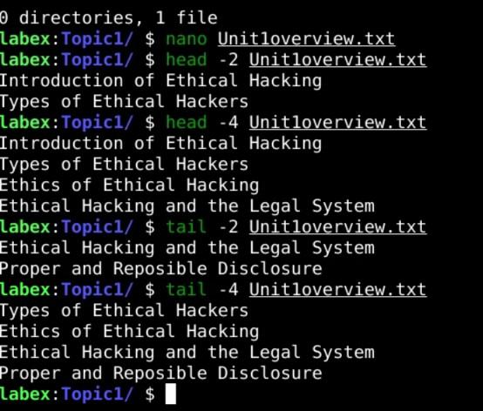

RESULT
the results for the following commands in Kali Linux Operating Systems: Tree Head Tail
was successfully executed

